Cluster Network with OMR stack

Contents

1. Introduction 3
2. Workflow diagram to deploy the stack 3
3. Create stack for Cluster Network with instance pools 4
4. Plan the Job 8
5. Apply the Job 9
6. Destroy the stack 10

Introduction

Cluster networks use instance pools to manage groups of identical high performance computing (HPC), GPU, or optimized instances that are connected with a high-bandwidth, ultra low-latency network. Each node in the cluster is a bare metal machine located in close physical proximity to the other nodes. A remote direct memory access (RDMA) network between nodes provides latency as low as single-digit microseconds, comparable to on-premises HPC clusters.
Prerequisites:
Create an instance configuration for the instance pool that is managed by the cluster network.
Use the following settings:
Image: Click Change image, and then click Oracle images. Select the Oracle Linux HPC cluster networking image.
Shape: Click Change shape. Select Bare metal machine. Then, select a shape that supports cluster networks.
Supported Shapes:
- BM.HPC2.36
- BM.GPU.A100-v2.8
- BM.GPU4.8
- BM.Optimized3.36
Typically, to be able to create the multiple HPC, GPU, or optimized instances that are contained in a cluster network, developer must request a service limit increase.

Workflow diagram to deploy the stack
Below diagram shows how the Terraform Artifact are applied in the OCI. While creating a ORM stack, using terraform deliverables Init, Plan and Apply is the flow to provision the resource in the OCI. We can have the deliverables in any of below.

- GitLab/GitHub Repo
- Bitbucket
- Can be in folder/.zip in the local disk
- Object Storage Bucket
- Can be in compartment
- Oracle provided Template


Create stack for Cluster Network with instance pools

Go to OCI Console Developer Services Resource Manager Stacks select the compartment Create Stack
My Configuration Folder Browse Select the “cluster_network” folder that contains the terraform Upload
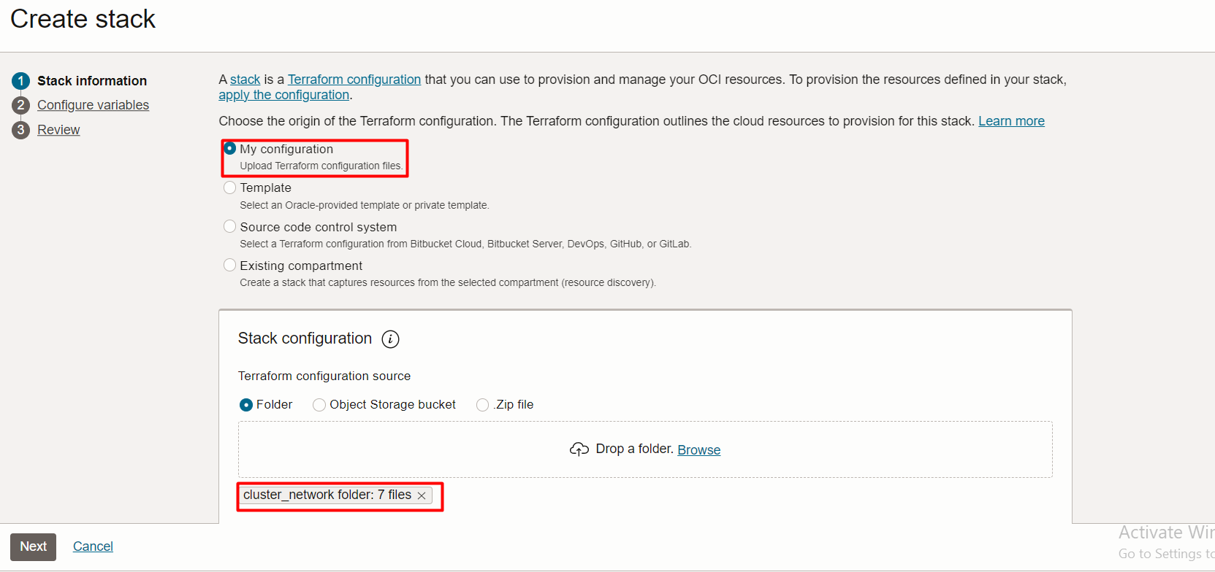
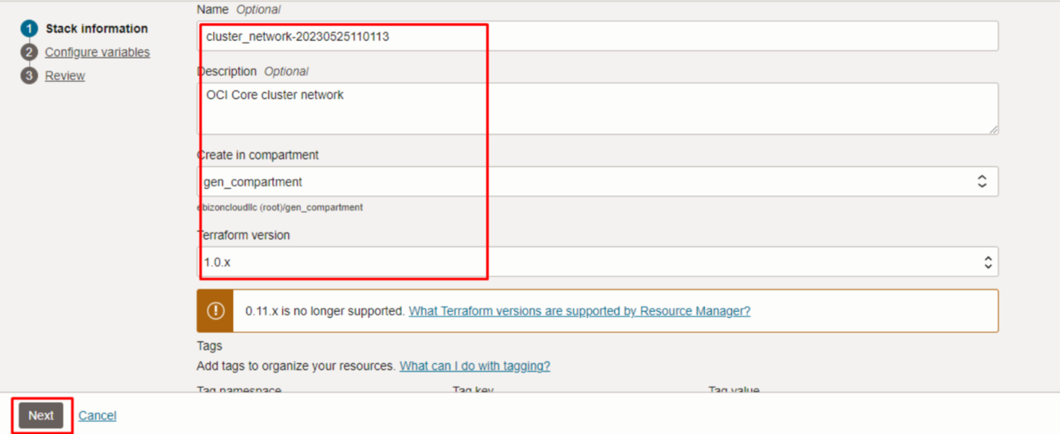
Click “NEXT”
Select the parameters as per the below screen,
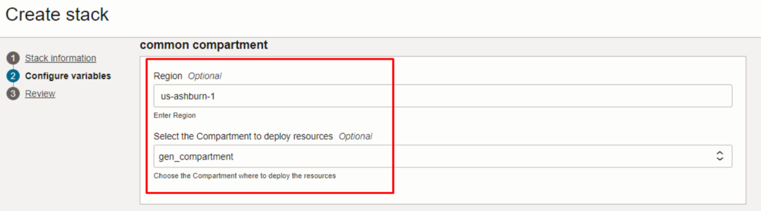

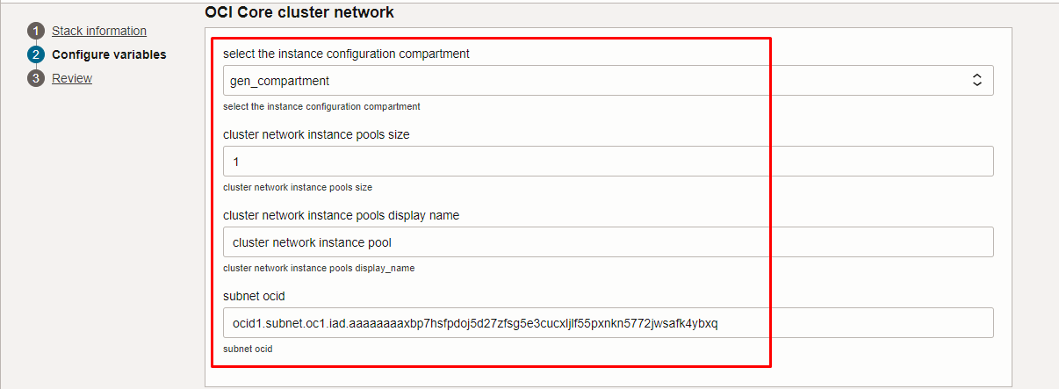
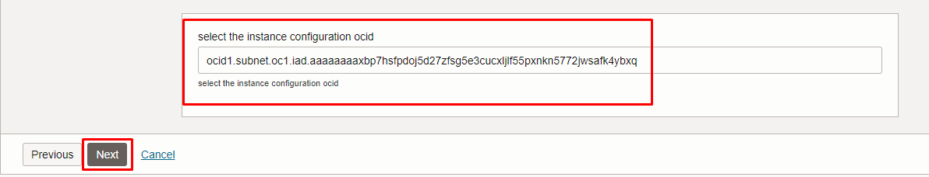

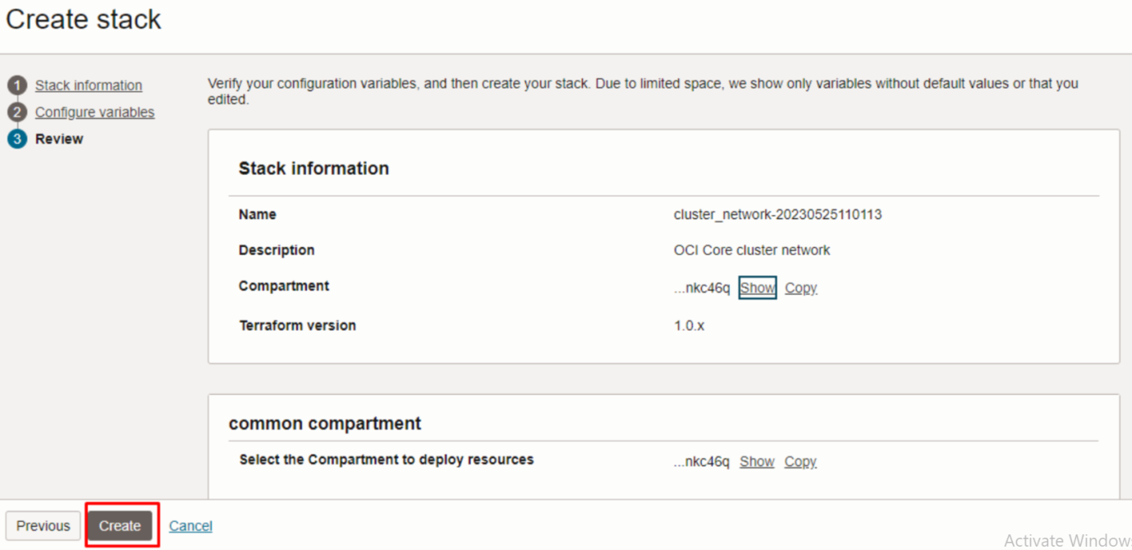

Click “NEXT” Click “CREATE”

Plan the Job

Click the “Plan”

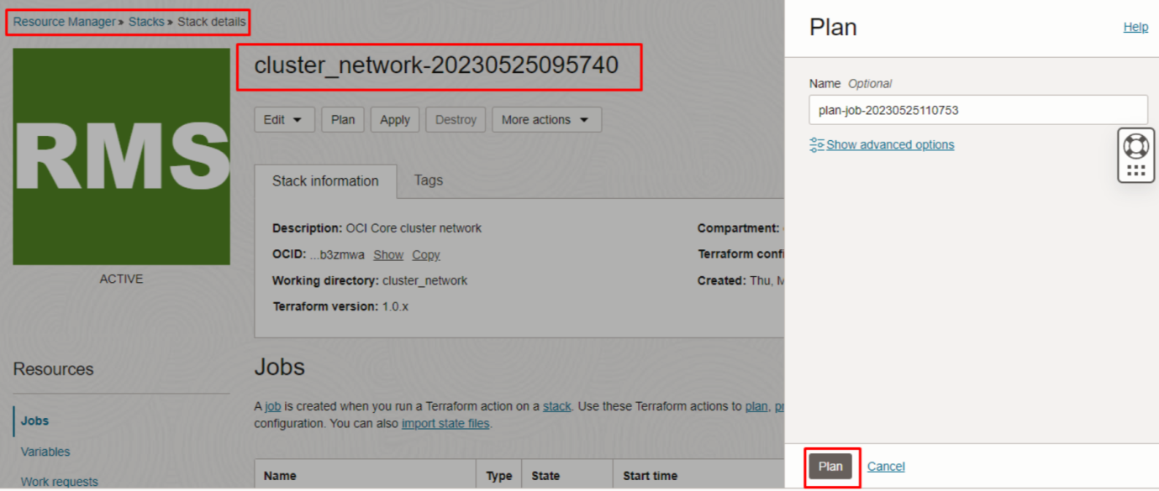

Verify the Plan is successful.
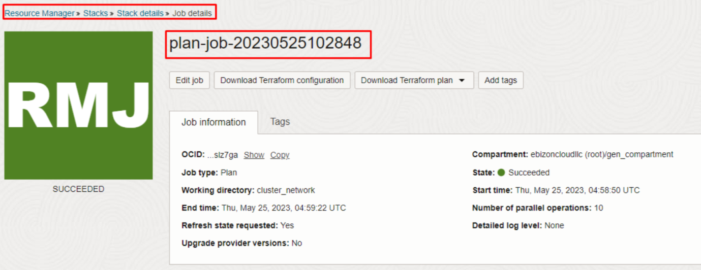

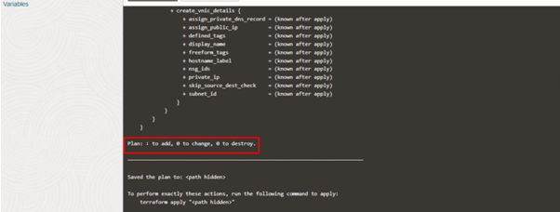

#END#

